No. 30 – August 2009

French words on the loose

“With French, it’s the imagination that travels,” states linguist Marie Treps. The researcher has been tracking down the words that have found a comfortable home in the 28 European countries into which the language has ventured – words that convey a certain image of France and the French.
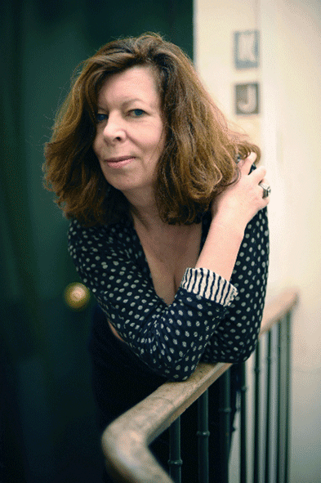
Marie Treps
© Seuil / E. Marchadour

French words have emigrated everywhere from Oslo to Madrid, Dublin to Istanbul and Lisbon to Riga. Marie Treps, a linguist at the French National Centre for Scientific Research, decided to set off in pursuit. Four years later, she has recorded her results in a work about a kind of French that “has been Europe’s cherished language” and which conveys a whole imaginary world.

So what do these migrants look like? “Almost everywhere in Europe, we might talk about a kind of drawing-room French, charming but a little old-fashioned. It’s also a kind of French that suggests something chic, a language people play with,” the researcher sums up. An obsolete form, then? In part, yes. A word that may be little used in France such as for example “boudoir”, is very widespread in European languages, or in German they say they are “bleu mourant” (deathly pale) when talking about being on the verge of fainting. "You find words that have survived from a kind of French that no longer exists, from the 17th century and the Age of Enlightenment,” explains Marie Treps. “Sometimes people use French to show that they are well educated,” she continues. Some expressions, such as “enfant gâté” (literally a ‘spoilt child’), “noblesse oblige”, and a feeling of “déjà-vu” are used in all kinds of contexts in Russia or the United Kingdom. There is also a playful aspect in the way these words are used, as "people who use French words often do it for their own amusement," the linguist points out. And she describes how “pals like pigs” (the literal translation of the French phrase, “copains comme cochons” meaning “as thick as thieves”) led to “amikosonstvo” in Russian or “guillotiner” produced “gilotynowac”, which means “to interrupt a conversation suddenly” in Polish.

Not surprisingly, certain registers of language have supplied a plethora of words. This is the case of the culinary arts and fashion, and words related to housing and cities. So “omelette” and “gratin” are to be found everywhere, and in Greece you even have “pourés-zambon” for “purée-jambon” (ham and mashed potatoes). You will also hear words such as “déshabillé” (negligee), “costume” and in Turkey, “robe de chambre” (dressing gown), as well as “chaise longue”, “parquet”, “terrasses”, “garages” and “passages”. Words linked to technology have also broken free. Examples include railway vocabulary such as “locomotive” and car terminology such as “embrayage” (clutch), “carburateur” (carburettor) and “bougie” (spark plug). “These are words from modern times. They have been followed by diapo (slide), prospectus and many more besides,” says Marie Treps. In the world of diplomacy, “terms such as “lettres de créance”, “consulat”, “ambassade” and, “ministère” crop up all over the place.”

Great inventiveness

French has also been influential in the defence of liberties and emancipation. “It has played a particularly important role as the language of resistance. Young people in Bulgaria, for example, used it to create a slang in the Soviet period enabling them to talk about certain things between themselves,” explains the linguist. This slang is still alive today. Thus “abdiquer” (literally, ‘abdicate’) gave rise to “abdikiram” and means “to skip class” and “garderob” is used to talk about a sturdy individual acting as a match steward.

Each culture’s imagination comes into play in these kinds of borrowings. “Individuals adapt words to suit their own whims. There’s a lot of inventiveness involved,” she observes. This is where some of the false friends come in. The familiar word “couillon” which in French means an imbecile, for example, has had an astonishing fate. In Norway it means ‘a coward’, in Poland ‘a student who does his revision at the last minute’, and in Russia ‘a sex machine’.

The choice of words can also reveal the perception their European neighbours have of the French. And it’s quite a contrasting picture. “There are some very positive things and others that are not so complimentary. Words that have migrated, for example, include “brutal”, “absurde” and “pédant” but you also find “discret”, “charmant” and “chic”. “Filer à la française” (‘to do a runner’) can mean either leaving without paying or in a rude manner.” There is also a whole vocabulary, which we will not go into here, which might even suggest that the French were people of loose morals.

Florence Raynal

